UNIT III
BIPOLAR JUNCTION TRANSISTOR
3.1 INTRODUCTION
A bipolar junction transistor (BJT) is a three terminal device in which operation depends on the interaction of both majority and minority carriers and hence the name bipolar. The BJT is analogus to vacuum triode and is comparatively smaller in size. It is used i amplifier and oscillator circuits, and as a switch in digital circuits. It has wide applications in computers, satellites and other modern communication systems.
3.2 CONSTRUCTION OF BJT AND ITS SYMBOLS
The Bipolar Transistor basic construction consists of two PN-junctions producing three connecting terminals with each terminal being given a name to identify it from the other two. These three terminals are known and labelled as the Emitter ( E ), the Base ( B ) and the Collector ( C ) respectively. There are two basic types of bipolar transistor construction, PNP and NPN, which basically describes the physical arrangement of the P-type and N-type semiconductor materials from which they are made.
Transistors are three terminal active devices made from different semiconductor materials that can act as either an insulator or a conductor by the application of a small signal voltage. The transistor's ability to change between these two states enables it to have two basic functions: "switching" (digital electronics) or "amplification" (analogue electronics). Then bipolar transistors have the ability to operate within three different regions:
- 1. Active Region - the transistor operates as an amplifier and Ic = β.Ib
- 2. Saturation - the transistor is "fully-ON" operating as a switch and Ic = I(saturation)
- 3. Cut-off - the transistor is "fully-OFF" operating as a switch and Ic = 0
Bipolar Transistors are current regulating devices that control the amount of current flowing through them in proportion to the amount of biasing voltage applied to their base terminal acting like a current-controlled switch. The principle of operation of the two transistor types PNP and NPN, is exactly the same the only difference being in their biasing and the polarity of the power supply for each type(fig 1).

Bipolar Transistor Construction
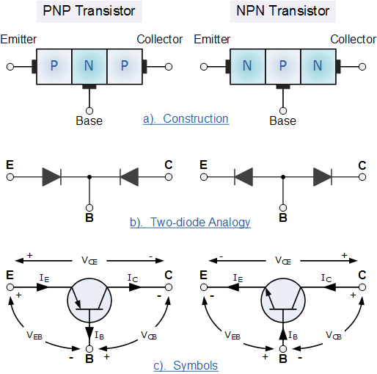
- Fig:1
The construction and circuit symbols for both the PNP and NPN bipolar transistor are given above with the arrow in the circuit symbol always showing the direction of "conventional current flow" between the base terminal and its emitter terminal. The direction of the arrow always points from the positive P-type region to the negative N-type region for both transistor types, exactly the same as for the standard diode symbol.

3.3 TRANSISTOR CURRENT COMPONENTS:

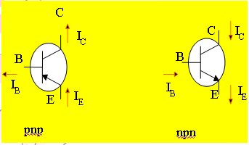
FIG 2
The above fig 2 shows the various current components, which flow across the forward biased emitter junction and reverse- biased collector junction. The emitter current I_{E} consists of hole current I_{PE} (holes crossing from emitter into base) and electron current I_{nE} (electrons crossing from base into emitter).The ratio of hole to electron currents, I_{pE /} I_{nE} , crossing the emitter junction is proportional to the ratio of the conductivity of the p material to that of the n material. In a transistor, the doping of that of the emitter is made much larger than the doping of the base. This feature ensures (in p-n-p transistor) that the emitter current consists an almost entirely of holes. Such a situation is desired since the current which results from electrons crossing the emitter junction from base to emitter does not contribute carriers, which can reach the collector.
Not all the holes crossing the emitter junction J_{E} reach the the collector junction J_{C}
Because some of them combine with the electrons in n-type base. If I_{pC} is hole current at junction J_{C} there must be a bulk recombination current ( I_{PE-} I_{pC} ) leaving the base.

Actually, electrons enter the base region through the base lead to supply those charges, which have been lost by recombination with the holes injected in to the base across J_{E.} If the emitter were open circuited so that I_{E}=0 then I_{pC} would be zero. Under these circumstances, the base and collector current I_{C} would equal the reverse saturation current I_{CO.} If I_{E}≠0 then
I_{C}= I_{CO}- I_{pC}
For a p-n-p transistor, I_{CO} consists of holes moving across J_{C from} left to right (base to collector) and electrons crossing J_{C} in opposite direction. Assumed referenced direction for I_{CO} i.e. from right to left, then for a p-n-p transistor, I_{CO is} negative. For an n-p-n transistor, I_{CO} is positive.The basic operation will be described using the pnp transistor. The operation of the pnp transistor is exactly the same if the roles played by the electron and hole are interchanged.
One p-n junction of a transistor is reverse-biased, whereas the other is forward-biased.
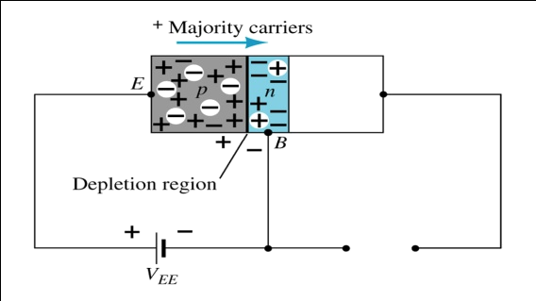
Forward-biased junction of a pnp transistor
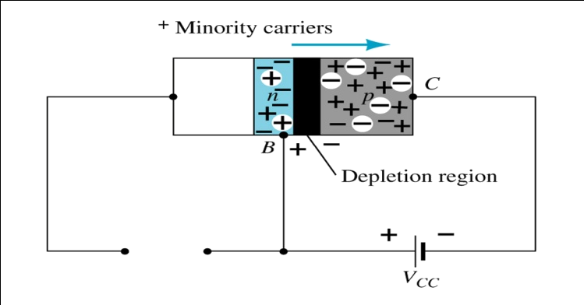
Reverse-biased junction of a pnp transistor
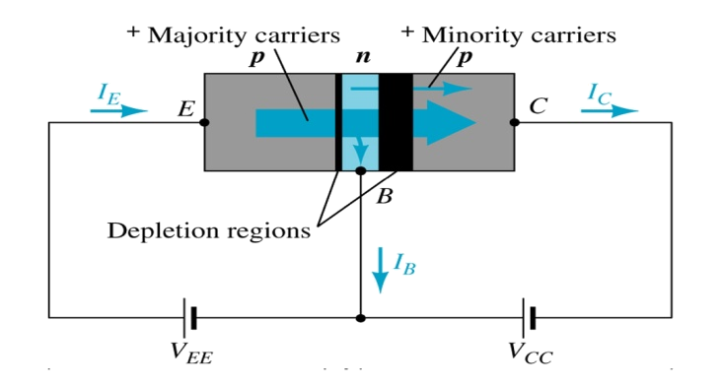
Both biasing potentials have been applied to a pnp transistor and resulting majority and minority carrier flows indicated.
Majority carriers (+) will diffuse across the forward-biased p-n junction into the n-type material.
A very small number of carriers (+) will through n-type material to the base terminal. Resulting IB is typically in order of microamperes.
The large number of majority carriers will diffuse across the reverse-biased junction into the p-type material connected to the collector terminal
Applying KCL to the transistor :
I_{E} = I_{C} + I_{B}
The comprises of two components – the majority and minority carriers
I_{C} = I_{Cmajority} + I_{COminority}
I_{CO} – I_{C} current with emitter terminal open and is called leakage current
Various parameters which relate the current components is given below
Emitter efficiency:
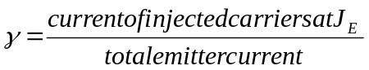
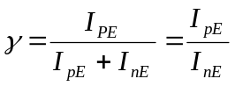
Transport Factor:
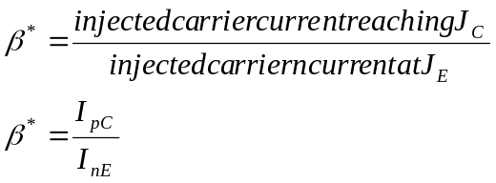
Large signal current gain:
The ratio of the negative of collector current increment to the emitter current change from zero (cut-off)to I_{E} the large signal current gain of a common base transistor.
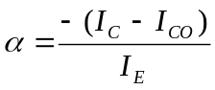
Since I_{C and} I_{E} have opposite signs, then α, as defined, is always positive. Typically numerical values of α lies in the range of 0.90 to 0.995
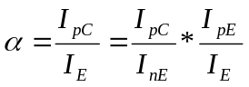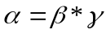
The transistor alpha is the product of the transport factor and the emitter efficiency. This statement assumes that the collector multiplication ratio 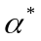is unity. 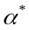is the ratio of total current crossing J_{C} to hole arriving at the junction.

3.4 Bipolar Transistor Configurations
As the Bipolar Transistor is a three terminal device, there are basically three possible ways to connect it within an electronic circuit with one terminal being common to both the input and output. Each method of connection responding differently to its input signal within a circuit as the static characteristics of the transistor vary with each circuit arrangement.
- 1. Common Base Configuration - has Voltage Gain but no Current Gain.
- 2 Common Emitter Configuration - has both Current and Voltage Gain.
- 3. Common Collector Configuration - has Current Gain but no Voltage Gain.
3.5 COMMON-BASE CONFIGURATION
Common-base terminology is derived from the fact that the : base is common to both input and output of t configuration. base is usually the terminal closest to or at ground potential. Majority carriers can cross the reverse-biased junction because the injected majority carriers will appear as minority carriers in the n-type material. All current directions will refer to conventional (hole) flow and the arrows in all electronic symbols have a direction defined by this convention.
Note that the applied biasing (voltage sources) are such as to establish current in the direction indicated for each branch.
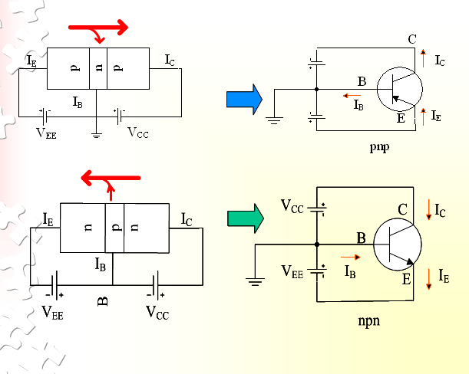
To describe the behavior of common-base amplifiers requires two set of characteristics:
- Input or driving point characteristics.
- Output or collector characteristics
The output characteristics has 3 basic regions:
- Active region –defined by the biasing arrangements
- Cutoff region – region where the collector current is 0A
- Saturation region- region of the characteristics to the left of V_{CB} = 0V
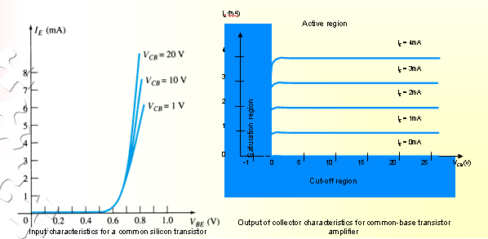

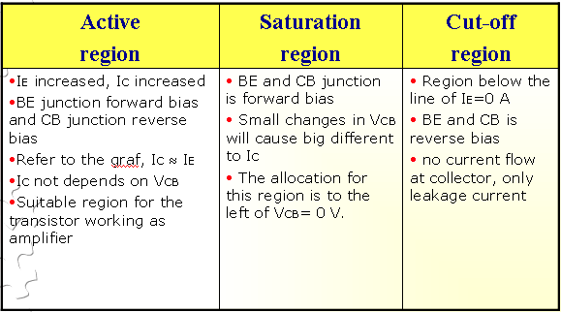
The curves (output characteristics) clearly indicate that a first approximation to the relationship between IE and IC in the active region is given by
I_{C} ≈IE
Once a transistor is in the ‘on’ state, the base-emitter voltage will be assumed to beV_{BE} = 0.7V
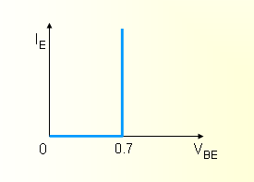
In the dc mode the level of I_{C} and I_{E} due to the majority carriers are related by a quantity called alpha α= α_{dc}
I_{C} = αI_{E} + I_{CBO}
It can then be summarize to I_{C} = αI_{E} (ignore I_{CBO} due to small value)
For ac situations where the point of operation moves on the characteristics curve, an ac alpha defined by α_{ac}
Alpha a common base current gain factor that shows the efficiency by calculating the current percent from current flow from emitter to collector. The value of α is typical from 0.9 ~ 0.998.
Biasing:Proper biasing CB configuration in active region by approximation I_{C} ≈ I_{E} (I_{B} ≈ 0 uA)
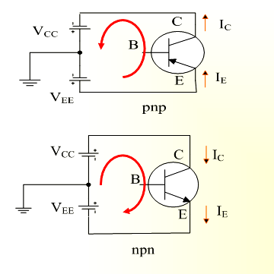
3.6 TRANSISTOR AS AN AMPLIFIER
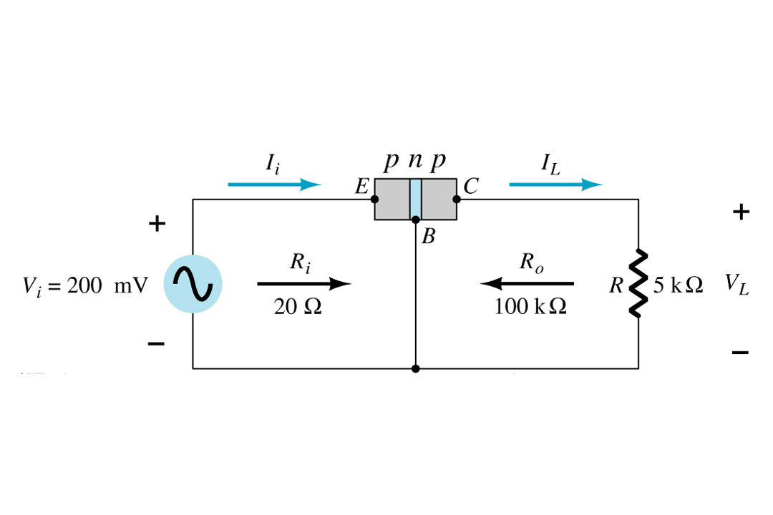
Common-Emitter Configuration
It is called common-emitter configuration since : emitter is common or reference to both input and output terminals.emitter is usually the terminal closest to or at ground potential.
Almost amplifier design is using connection of CE due to the high gain for current and voltage.
Two set of characteristics are necessary to describe the behavior for CE ;input (base terminal) and output (collector terminal) parameters.
Proper Biasing common-emitter configuration in active region
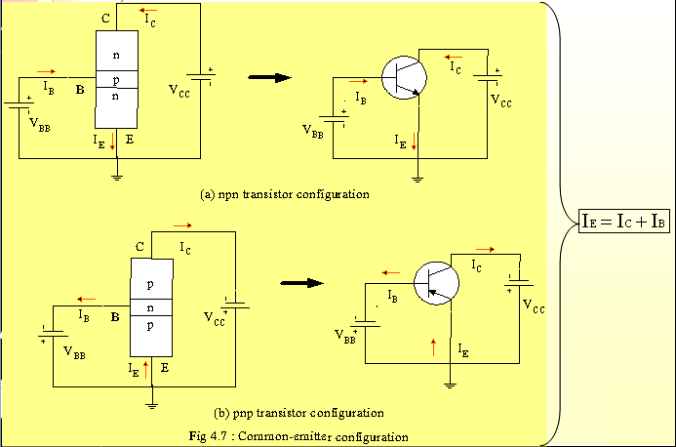

I_{B} is microamperes compared to miliamperes of I_{C}.
I_{B} will flow when V_{BE} > 0.7V for silicon and 0.3V for germanium
Before this value I_{B} is very small and no I_{B}.
Base-emitter junction is forward bias Increasing V_{CE} will reduce I_{B} for different values.

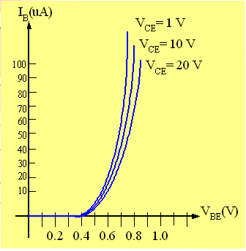

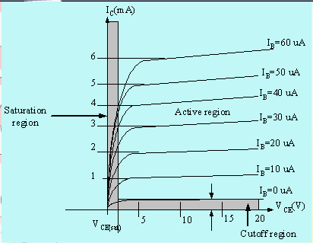
Output characteristics for acommon-emitter npn transistor
For small V_{CE} (V_{CE} < V_{CESAT}, I_{C} increase linearly with increasing of V_{CE}
V_{CE} > V_{CESAT} I_{C} not totally depends on V_{CE} à constant I_{C}
I_{B}(uA) is very small compare to I_{C} (mA). Small increase in I_{B} cause big increase in I_{C}
I_{B}=0 A à I_{CEO} occur.
Noticing the value when I_{C}=0A. There is still some value of current flows.

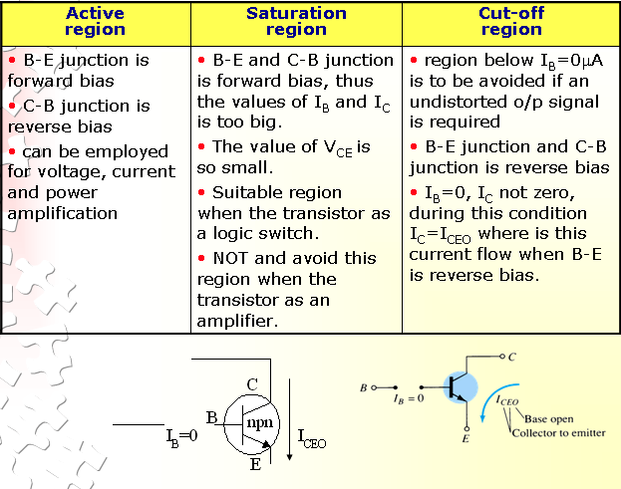
Beta (β) or amplification factor
The ratio of dc collector current (IC) to the dc base current (IB) is dc beta (βdc ) which is dc current gain where IC and IB are determined at a particular operating point, Q-point (quiescent point). It’s define by the following equation:
30 < βdc < 300 à 2N3904
On data sheet, β_{dc}=hfe with h is derived from ac hybrid equivalent cct. FE are derived from forward-current amplification and common-emitter configuration respectively.
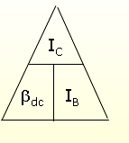

For ac conditions, an ac beta has been defined as the changes of collector current (I_{C}) compared to the changes of base current (I_{B}) where I_{C} and I_{B} are determined at operating point. On data sheet, β_{ac}=hfe It can defined by the following equation:
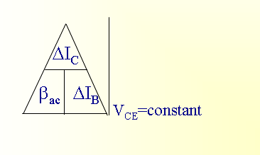

From output characteristics of commonemitter configuration, find β_{ac} and β_{dc} with an
Operating point at I_{B}=25 μA and V_{CE} =7.5V
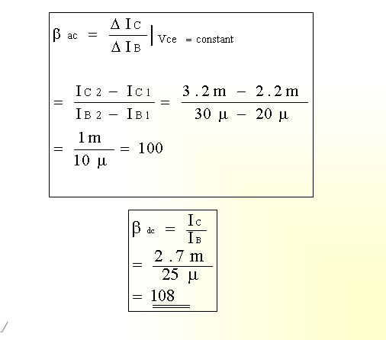
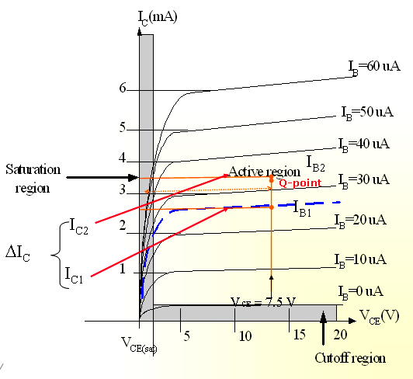

Relationship analysis between α and β
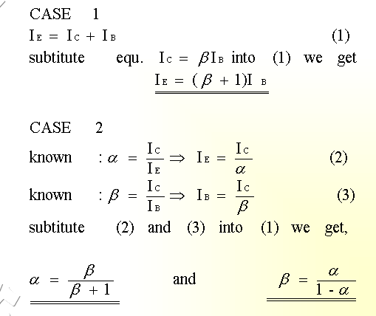
3.7 COMMON – COLLECTOR CONFIGURATION
Also called emitter-follower (EF). It is called common-emitter configuration since both the signal
source and the load share the collector terminal as a common connection point.The output voltage is obtained at emitter terminal. The input characteristic of common-collector configuration is similar with common-emitter. configuration.Common-collector circuit configuration is provided with the load resistor connected from emitter to ground.It is used primarily for impedance-matching purpose since it has high input impedance and low output impedance.
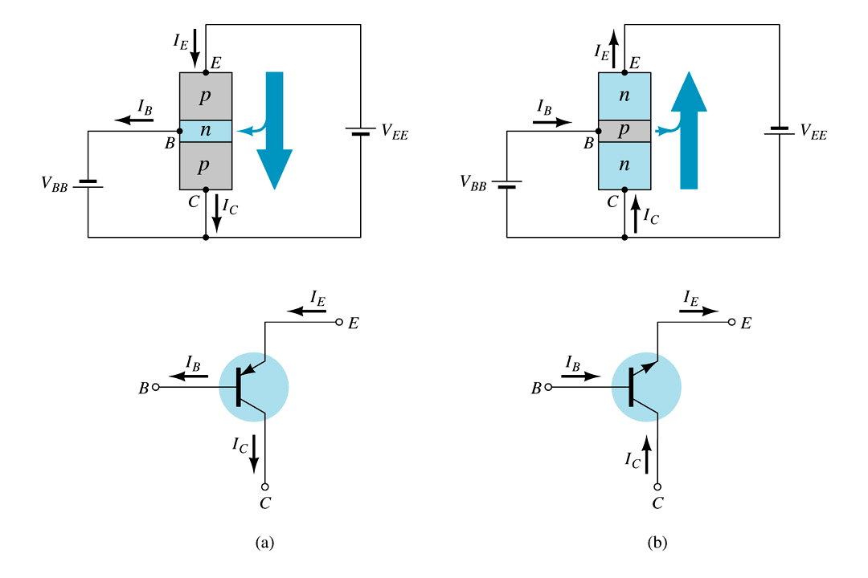

For the common-collector configuration, the output characteristics are a plot of I_{E} vs V_{CE} for a range of values of I_{B}.
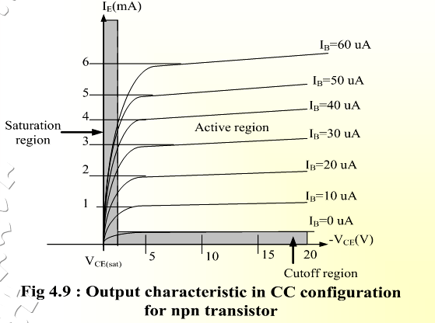
Limits of opearation
Many BJT transistor used as an amplifier. Thus it is important to notice the limits of operations.At least 3 maximum values is mentioned in data sheet.
There are:
a) Maximum power dissipation at collector: P_{Cmax} or P_{D}
b) Maximum collector-emitter voltage: V_{CEmax} sometimes named as V_{BR(CEO}) or V_{CEO}.
c) Maximum collector current: ICmax

There are few rules that need to be followed for BJT transistor used as an amplifier. The rules are: transistor need to be operate in active region!
I_{C} < I_{Cmax}
P_{C} < P_{Cmax}
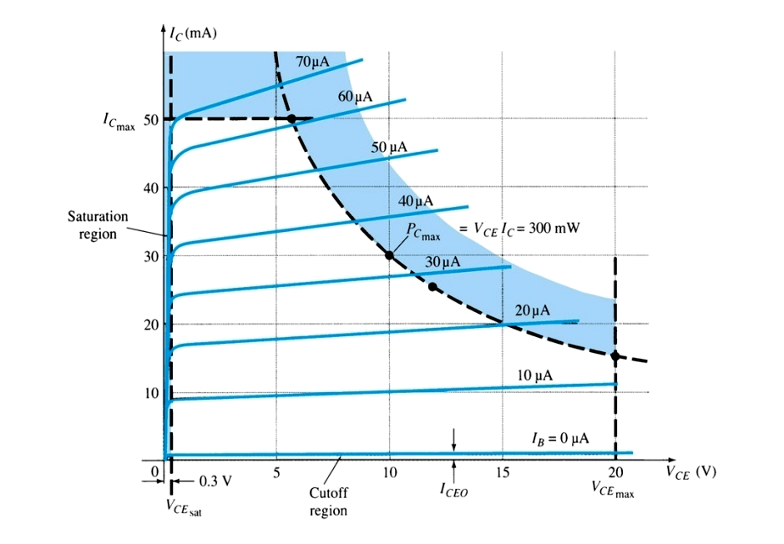

Note: V_{CE} is at maximum and I_{C} is at minimum (I_{CMAX}=I_{CEO}) in the cutoff region. I_{C} is at maximum and V_{CE} is at minimum (V_{CE} max = V_{cesat} = V_{CEO}) in the saturation region. The transistor operates in the active region between saturation and cutoff.
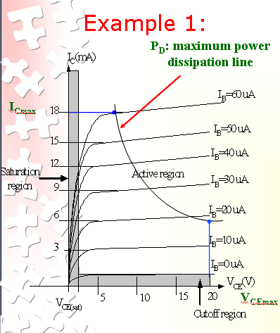

Refer to the fig. Example; A derating factor of 2mW/°C indicates the power dissipation is reduced 2mW each degree centigrade increase of temperature.

Step1:
The maximum collector power dissipation,
P_{D}=I_{CMAX} x V_{CEmax}= 18m x 20 = 360 mW
Step 2:
At any point on the characteristics the product of and must be equal to 360 mW.
Ex. 1. If choose I_{Cmax}= 5 mA, substitute into the (1), we get
V_{CEmax}I_{Cmax}= 360 mW
V_{CEmax}(5 m)=360/5=7.2 V
Ex.2. If choose V_{CEmax}=18 V, substitute into (1), we get
V_{CEmax}I_{Cmax}= 360 mW
(10) I_{CMAX}=360m/18=20 mA
Derating P_{Dmax}
P_{DMAX} is usually specified at 25°C.
The higher temperature goes, the less is P_{DMAX}
Example;A derating factor of 2mW/°C indicates the power dissipation is reduced 2mW each degree centigrade increase of temperature.

